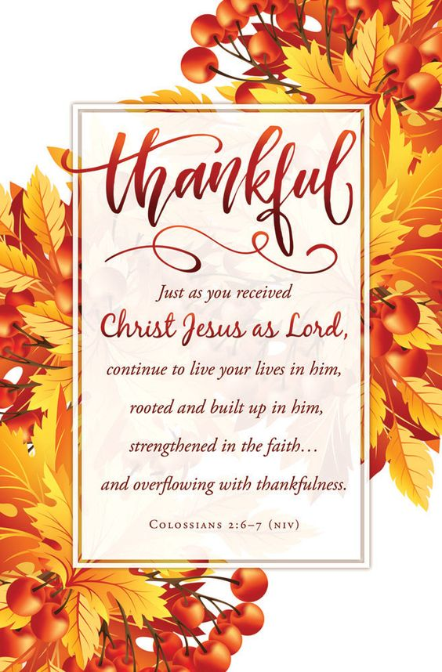

Welcome To
Trinity Lutheran Church
Lutheran Church—Missouri Synod
A Stephen Ministry Congregation

1354 South Otsego Avenue
Gaylord, Michigan 49735
Church Phone: (989) 732-4816

November 23, 2022
Thanksgiving Eve Service
Preacher: Rev. Ken Bernthal

ABOUT OUR WORSHIP
We welcome all who gather here today! We are blessed to celebrate together the mercy, grace, and love we have from God through the death and resurrection of our Lord Jesus Christ.

Children: Families with children are very welcome here. Having children in church is important so they can begin to learn about their faith in Jesus, and it’s good for the whole congregation to see. Please feel comfortable keeping “squirmy” kids in the service. This is where they belong, too!

Pew Cards: Guests and Members, please fill out the Guest/Member card located on the back of the pew in front of you and pass it to the end of the aisle. If you forget you can put it in the offering plate on your way out.

If standing is difficult: Please feel free to remain seated during any portion of the service. Please let an Elder or Usher know if you need communion in your pew seat.

About our celebration of Holy Communion: We celebrate the Lord’s Supper in the confession and glad confidence that, as he says, our Lord gives into our mouths not only bread and wine but his very body and blood to eat and to drink for the forgiveness of sins and to strengthen our union with him and with one another. Our Lord invites to his table those who trust his words, repent of all sin, and set aside any refusal to forgive and love as he forgives and loves us, that they may show forth his death until he comes.
Because those who eat and drink our Lord’s body and blood contrary to that which is stated above do so to their great harm, and also because Holy Communion is a confession of the faith which is confessed at this altar. Anyone who is not yet instructed, in doubt, or who hold a confession differing from that of the Lutheran Church—Missouri Synod, and yet desire to receive the sacrament, are asked first to speak with Pastor. Those not communing are still invited to come forward for a blessing from Pastor, and you may indicate this by crossing your arms over your chest.
TTTTTT
GREETING
P Peace be with you.
C And also with you.

T ORDER OF SERVICE T
Thanksgiving Eve Service

OPENING HYMN
Come, Ye Thankful People, Come LSB 892
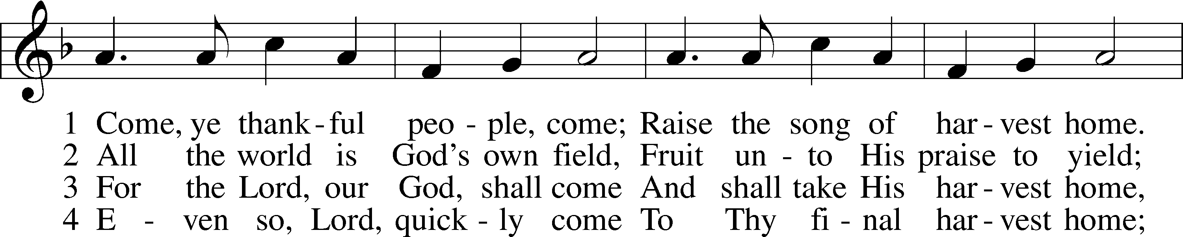
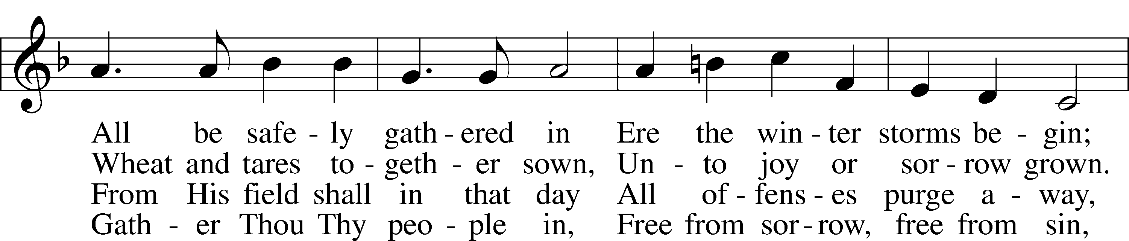
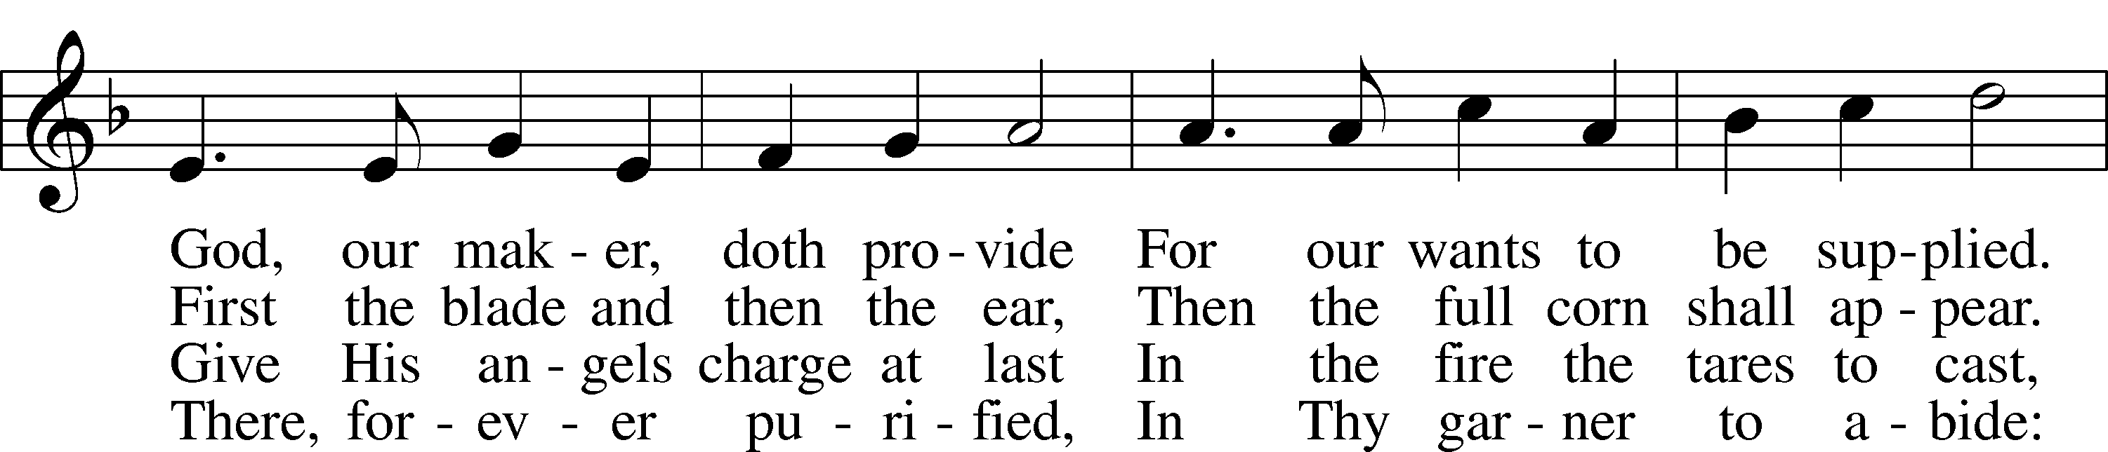
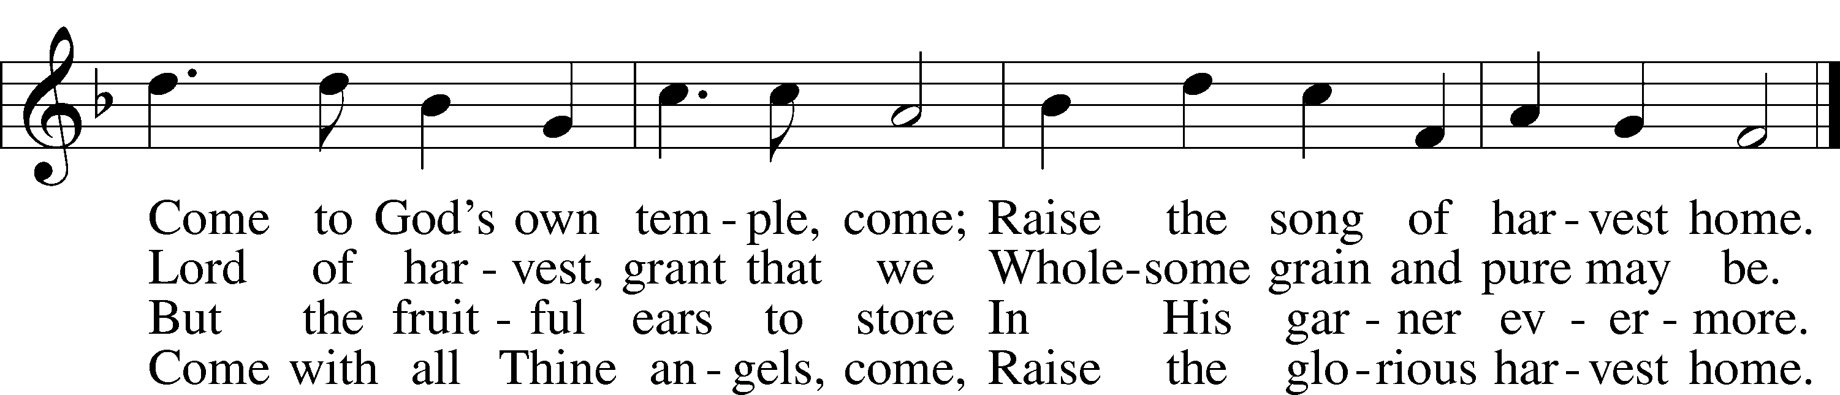

THE INVOCATION
Pastor: In the name of the Father and of the Son and of the Holy Spirit.
People: Amen.
Pastor: This is a day of praise
People: This is Your day, our Father. Like the pilgrims of the Plymouth
colony, we remember.
Pastor: We remember Your generous blessings of health, food, security, and friendship.
People: Accept our praise in this hour of jubilation. Amen.

THE PRAYER OF CONFESSION
Pastor: Lord, You know better than any of us that we live in the garden paradise
of Planet Earth. We Marvel at our vast harvests already stored in grain elevators and frozen food lockers. Lord, forgive us if we forget
that it was You who created the seed and nourished it with Your miraculous combination of rain, sunshine, and humus. Forgive us if we gather around our table and forget about those families who are painfully separated by the military base, the hospital bed, and the lonely college dormitory.
People: Lord, make us joyful and grateful for what we have. Keep our
families united in the humility of gratitude. May our lives together be healthful and hopeful until You call us to Your eternal home. Amen.

THE PSALMODY Psalm 100 (spoken responsively)
Pastor: Shout for joy to the Lord, all the earth.
People Serve the Lord with gladness; come before Him with joyful songs.
Pastor: Know that the Lord is God.
People: It is He who made us, and we are His; we are His people the sheep
of His pasture.
Pastor: Enter His gates with thanksgiving and His courts with praise.
People: Give thanks to Him and praise His Name.
Pastor: For the Lord is good and His love endures forever.
People: His faithfulness continues through all generations.
Pastor: Glory be to the Father and to the Son and to the Holy Spirit.
People: As it was in the beginning, is now, and will be forever. Amen.

THE SCRIPTURE READING Psalm 65 NIV
¹ Praise awaits You, our God, in Zion;
to You our vows will be fulfilled.
² O You who hear prayer,
to You all men will come.
³ When we were overwhelmed by sins,
You atoned for our transgressions.
⁴ Blessed is the man You choose
and bring near to live in Your courts!
We are filled with the good things of Your house,
of Your holy temple.
⁵ You answer us with awesome deeds of righteousness,
O God our Savior,
the hope of all the ends of the earth
and of the farthest seas,
⁶ Who formed the mountains by Your power,
having armed Yourself with strength,
⁷ Who stilled the roaring of the seas,
the roaring of their waves,
and the turmoil of the nations.
⁸ Those living far away fear Your wonders;
where morning dawns and where evening fades,
You call forth songs of joy.
⁹ You care for the land and water it;
You enrich it abundantly.
The streams of God are filled with water
to provide the people with grain,
for so You have ordained it.
¹⁰ You drench its furrows and level its ridges;
You soften it with showers and bless its crops.
¹¹ You crown the year with Your bounty,
and Your carts overflow with abundance.
¹² The grasslands of the desert overflow;
the hills are clothed with gladness.
¹³ The meadows are covered with flocks
and the valleys are mantled with grain;
they shout for joy and sing.

THE HYMN
Sing to the Lord of Harvest LSB 893
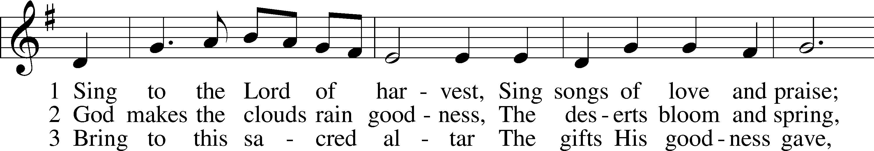
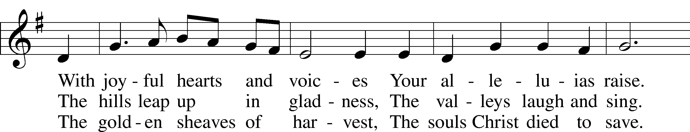
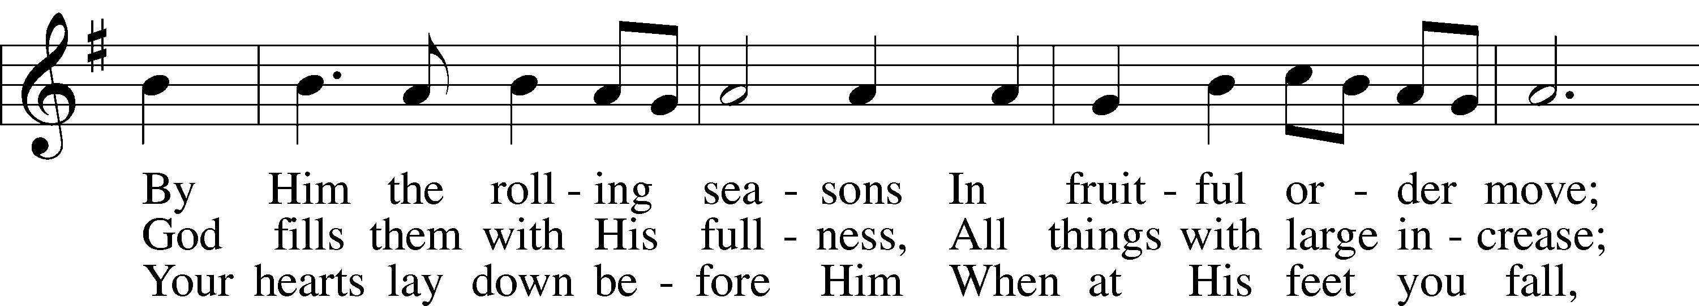
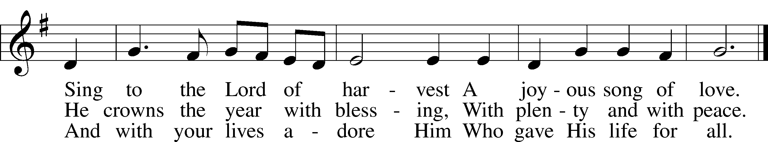

THE SERMON

THE HYMN
We Praise You, O God LSB 785
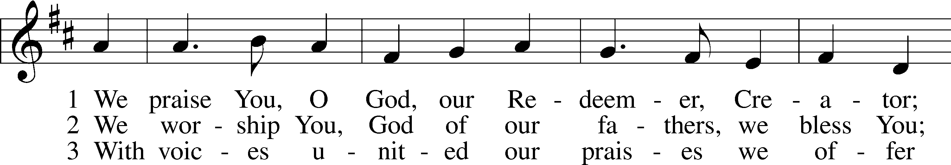
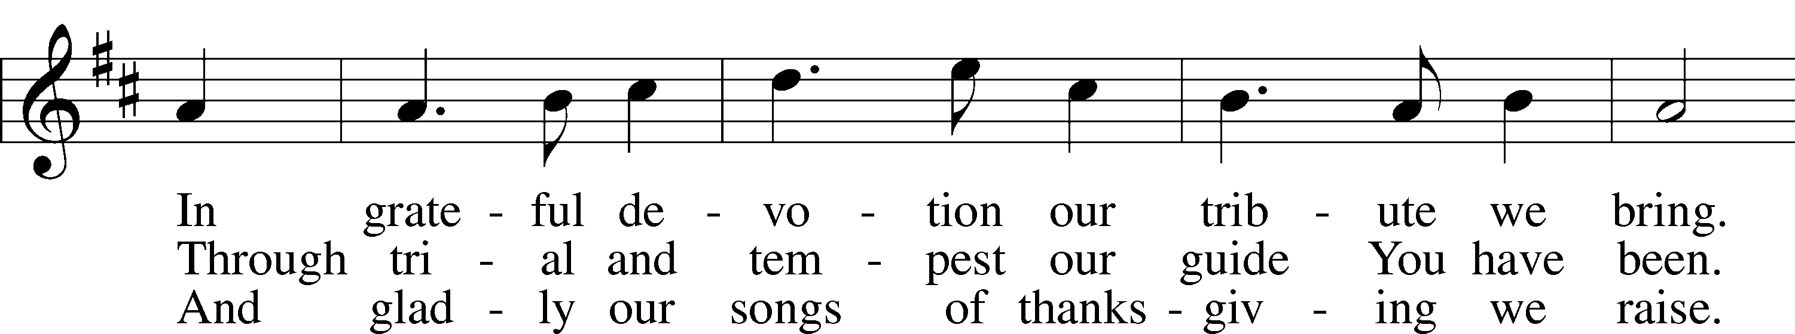
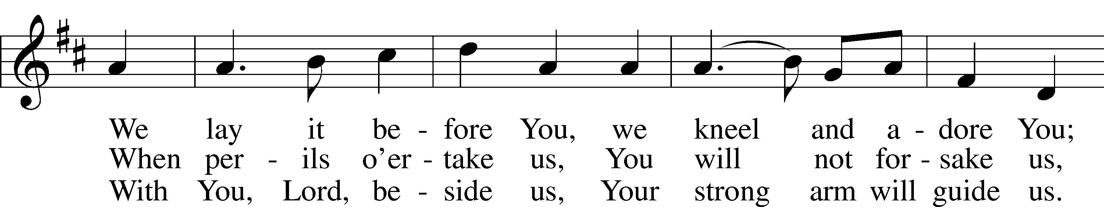
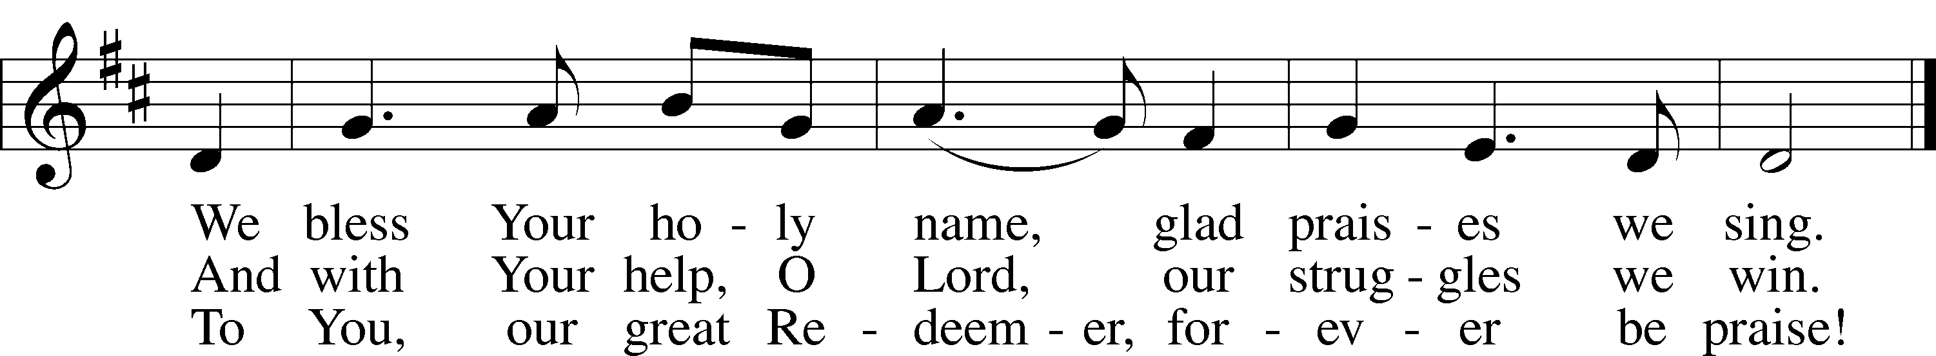

THE THANKSGIVING LITANY
Pastor: For the first of all days and its shining gifts
People: we give You thanks, O God!
Pastor: For fires and photons, for lasers and light and light shows, for color
and campfires, for energy and everything that springs from Your
bright gifts of light, we thank You.
People: And the evening and the morning were the first day, and it was good.
Pastor: For the second of days and its wet wonder,
People: we give You thanks, O God.
Pastor: For water below and above, for the beautiful blue of the sea and the sky, for
the rain that refreshes and the snow that sends shivers, for the atmosphere and all of the blessings that came down on Your second day of Creation, we thank you.
People: And the evening and the morning were the second day, and it was
good.
Pastor: For the green growing gifts of the third day,
People: we give You thanks, O God.
Pastor: For land dry and wet, for desert and bog, for canyons and cactus, for valleys
and vines, for fruits for our eating, and nuts we can shell, for awesome
oceans and plains of grains, for the earth and its bounty, we thank You.
People: And the evening and the morning were the third day, and it was good.
Pastor: For the fourth day and its heavenly lights,
People: we give You thanks, O God.
Pastor: For the beacon of the sun, for the lantern of the moon, for the mystery of the
planet and the stars, for sunny days and cool evenings, for seasons and
years, tides and time, we thank You.
People: And the evening and the morning were the fourth day, and it was good.
Pastor: For fluttering, floundering day number five,
People: we give You thanks, O God
Pastor: For all things that flap and flutter, squawk and chirp, for whales and
minnows, eagles and eggs, for everything that flies to the heights of
Your heavens and swims to the depths of Your oceans, we thank You.
People: And the evening and the morning were the fifth day, and it was good.
Pastor: For the sixth day and its grand glory
People: we give You thanks, O God.
Pastor: For things that creep and crawl, stalk and strut, for humans and hugs, for
ourselves and Your Son, Who entered this world to make us Your own
again, we thank You.
People: And the evening and the morning were the sixth day, and it was good.
Pastor: For the lazy luxury of the seventh day,
People: we give You thanks, O God.
Pastor: For pillows and hammocks, for mattresses and meditation, for workless
weekends and for worship, for the time to recharge and celebrate
Your creation so that we may praise You more, we thank You.
People: And it was very good! Amen.

THE LORDS PRAYER

Our Father who art in heaven,
Hallowed be thy name,
Thy kingdom come,
Thy will be done
On earth as it is in heaven.
Give us this day our daily bread;
And forgive us our trespasses
As we forgive those
Who trespass against us;
And lead us not into temptation,
But deliver us from evil.
For thine is the kingdom
And the power and the glory
Forever and ever. Amen.

THE CLOSING PRAYER

Pastor: Almighty God, whose mercies are new every morning and whose goodness, through undeserved, still abundantly provides for all our wants of body and soul, grant us, we humbly pray, Your Holy Spirit that we may heartily acknowledge Your merciful goodness towards us, give thanks for all Your benefits, and serve You in willing obedience; through Jesus Christ, Your Son, our Lord who lives and reigns with You and the Holy Spirit, one God, now and forever.
People: Amen.

BENEDICTION
Pastor: The Lord bless you and keep you.
The Lord make His face shine on you and be gracious to you.
The Lord look upon you with favor and T give you peace.
People: Amen.

THE CLOSING HYMN
For the Fruits of His Creation LSB 894
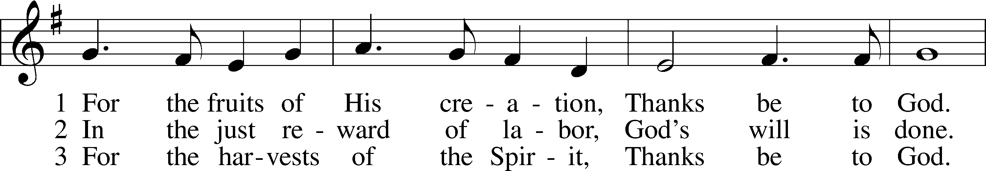
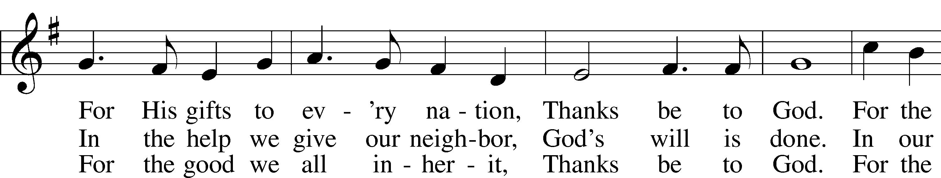
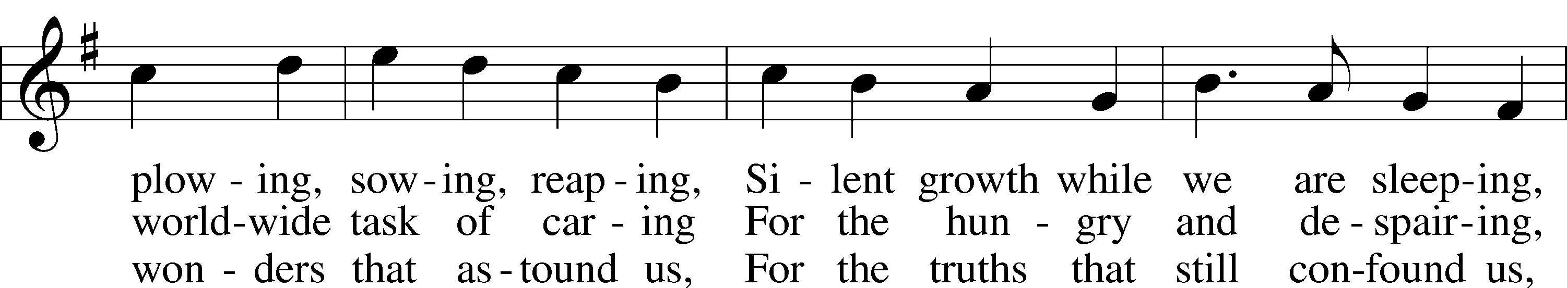
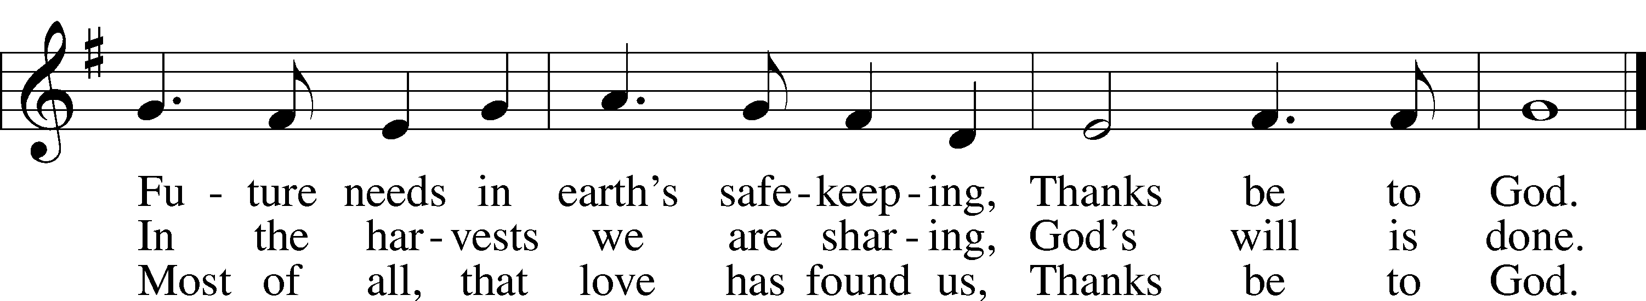

A SILENT PRAYER

PARISH ANNOUNCEMENTS

THE POSTLUDE

Acknowledgments
Unless otherwise indicated, Scripture quotations are from the ESV® Bible (The Holy Bible, English Standard Version®), copyright 2001 by Crossway, a publishing ministry of Good News Publishers. Used by permission. All rights reserved. Created by Lutheran Service Builder. Music reproduced in this service is used with permission through: CCLI License No.1776588 and CPH – LSB Service Builder.

PEOPLE WHO SERVE TODAY

Pastor: Rev. Ken Bernthal
Elder: Ken Mertz
Greeter/Ushers: Paul & Karen Schneider
Virtual Organist: Bob Erat

